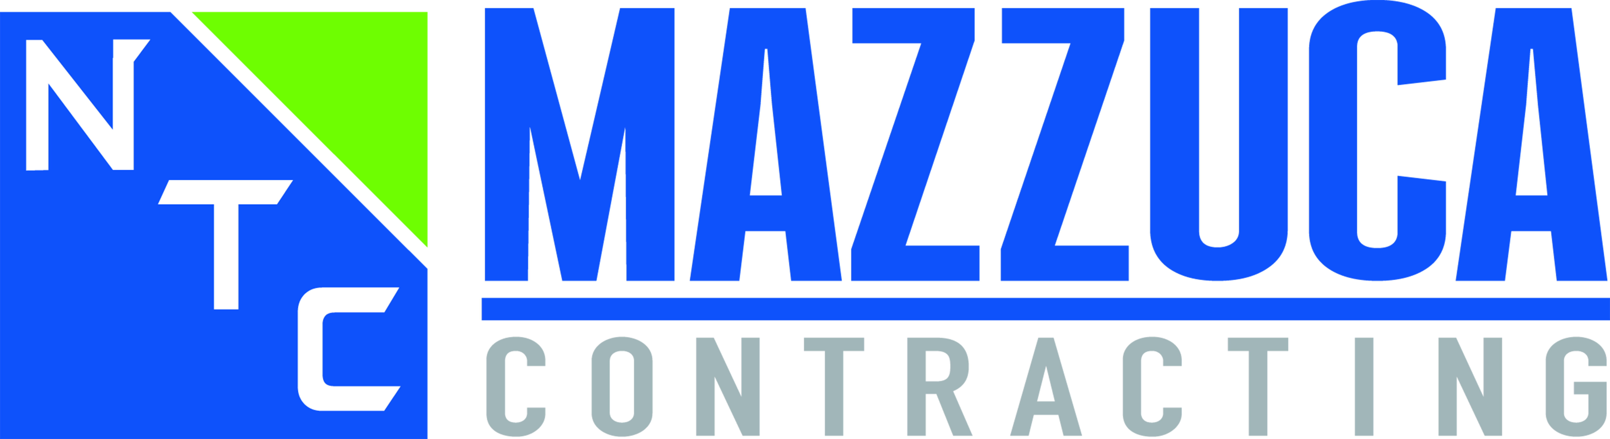
CERTIFICATE OF
INSURANCE INSTRUCTIONS

Subcontractor Certificate of Insurance Requirements

- General Liability: $1,000,000 Per Occurrence, $2,000,000 General Aggregate on a “primary basis” and $2,000,000 Products Completed Operations Aggregate, and a waiver of subrogation endorsement

- Automobile: $1,000,000 Combined Single Limit, Any Auto

- Workers Compensation and Employers Liability: Governing States Statutory Limits including a waiver of subrogation endorsement; Certificate of Insurance must remain in effect for thirty (30) days after project completion or until Subcontractor completes their punch list, whichever is longer, and have a thirty (30) day cancellation notice

- Environmental Liability: required with a limit of no less than $1,000,000 per claim if the services include sampling, testing or otherwise evaluating hazardous materials or substances, including their abatement, transportation and disposal.

- CERTIFICATE HOLDER: NTC Mazzuca Contracting, Inc. - 10907 Guilford Road, Suite A - Annapolis Junction, MD 20701

- ADDITIONAL INSURED: Certificate holder listed as Additional Insured under the General Liability including products and completed operations. Insurance is on a primary and non-contributory basis. Waiver of Subrogation in favor of NTC Mazzuca Contracting, Inc. with respect to Workers Compensation and General Liability. Should the Project Manual/Specifications require higher insurance limits than those stated in this Agreement, the Project Manual/Specifications shall supersede the requirements noted in this Agreement

- Certificate of Insurance must remain in effect for thirty (30) days after project completion or until Subcontractor completes their punch list, whichever is longer, and have a thirty (30) day cancellation notice.

(See Sample Cert. of Ins. Attached)

